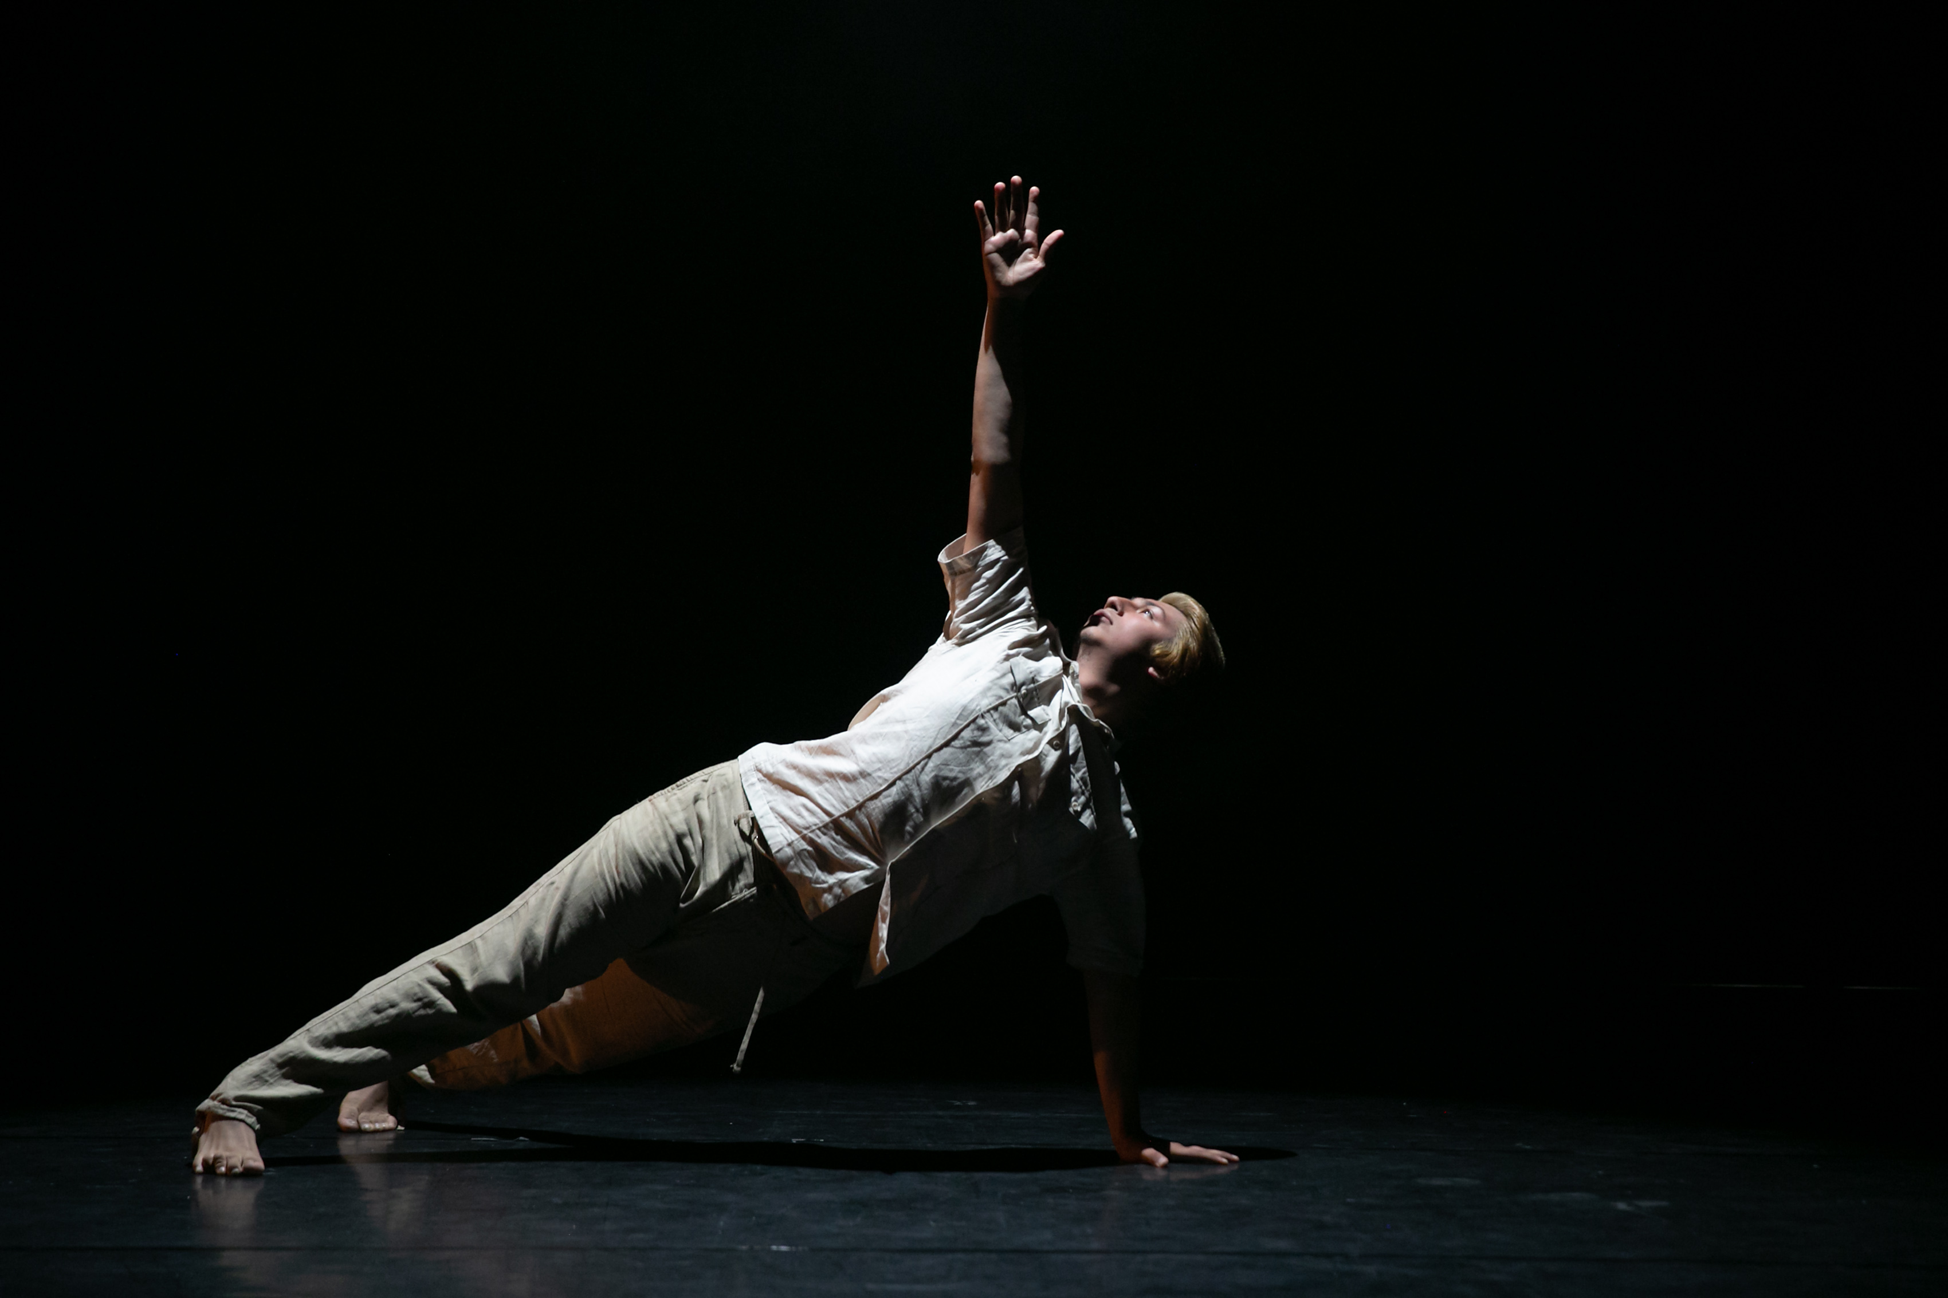
  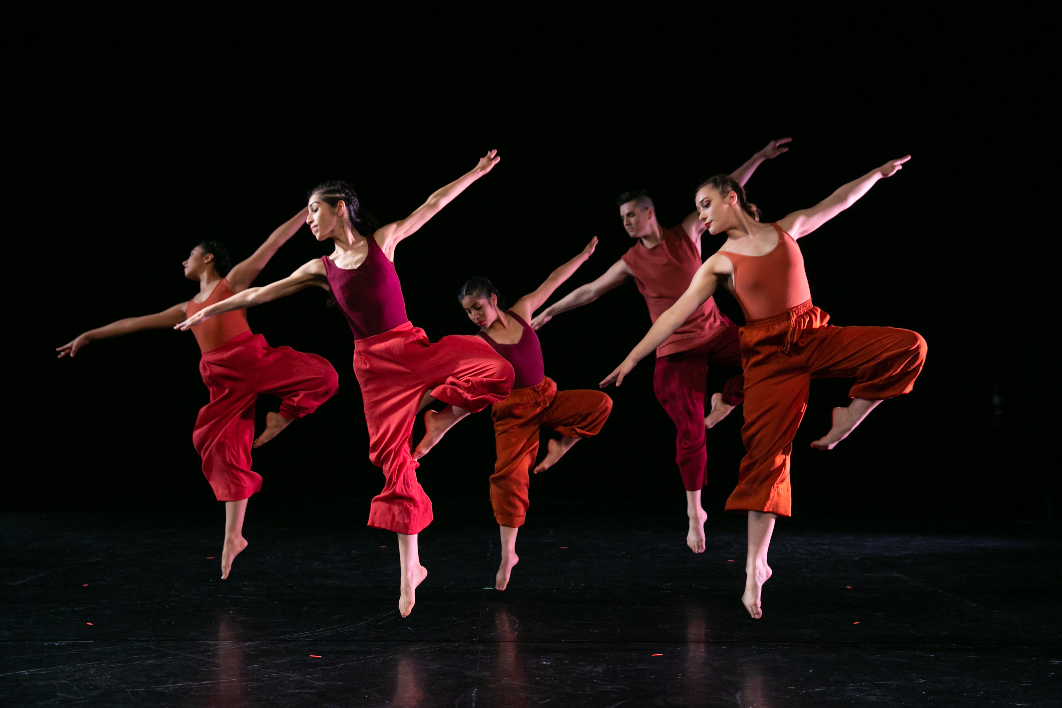
    - Virtual Live Dance Classes!
  STarting October 19
  Go to SAC.EDU/DANCE to check out our website.
  Reach for your goals with SAC DANCE!
  REGISTER
  NOW
  Ballet
  JAZZ
  MODERN
  Choreography
  Santa Ana College
  Dance Department
  Heather Gillette, Dept. Chair
  gillette_heather@sac.edu

